**MINITSRY OF EDUCATION AND TRAINING**

**UNIVERSE OF TECHNOLOGY AND EDUCATION**

**FACULTY OF HIGH QUALITY DEPARTMENT**

**-----------------⸙∆⸙-----------------**



**WEEK 5’S REPORT**

**Topic: Chapter 5’s report**

**Lecturer : Thái Hoàng Linh**

**Name : Trần Minh Quân**

**ID : 19151078**

**Tp. Hồ Chí Minh ngày 21 tháng 03 năm 2022**

Contents

1. 74LS151 2

1.1 Choosing different channel using button 2

1.2 PWM with 8 different level 2

2. 74LS148 4

2.1 Encoder 8_3 4

2.2 Encoder 8_3 and using ic74LS175 to latch the result. 5

2.3 Encoder 8_3 using two IC 74LS175 to latch the result and shift the previous result 6

3. 74LS138 8

3.1 Decoder decode after 4 clock pulse circuit 8

3.2 Decoder decode after 8 clock pulse circuit 9

3.3 Decoder decode after 128 clock pulse circuit 10

3.4 Decoder decode after 256 clock pulse circuit 10

3.5 Creating a decoder 4_16 using 2 decoder 3_8 11

3.6 Demultiplexer 12

3.7 Multiplexer and Demultiplexer with 8 chanel 13

4. 74LS139 14

4.1 Decoder 3_8 using 2 IC 74LS139 14

**Image’s page**

Figure 1: Choosing different channel using button 3

Figure 2: PWM with button to control LED 3

Figure 3: LED is on but not visibly 4

Figure 4: LED is on level 2 4

Figure 5: LED is on level 3 4

Figure 6: LED is on level 4 4

Figure 7: LED is on level 5 4

Figure 8: LED is on level 6 4

Figure 9: LED is on maxmimum effect 5

Figure 10: Encoder 8_3 5

Figure 11: Encoder 8_3 when pressing button 2 6

Figure 12:Encoder 8_3 using 74LS175 to latch the result 6

Figure 13: After letting go of the button 7

Figure 14: Encoder 8_3 using 2 IC 74LS175 to latch and shift the result 7

Figure 15: After pressing button Q1 8

Figure 16: After pressing button Q2 8

Figure 17: Decoder decode after 4 clock pulse circuit 9

Figure 18: Operating status of the circuit decoder decode after 4 clock pulse 10

Figure 19: Decoder decode after 8 clock pulse 10

Figure 20: Decoder decode after 128 clock pulse 11

Figure 21: Decoder decode after 256 clock pulse 11

Figure 22: Decoder 4_16 using 2 decoder 3_8 12

Figure 23: Demultiplexer 13

Figure 24: Multiplexer 14

Figure 25: Operating status of the multiplexer circuit 14

Figure 26: Decoder 3_8 using 2 IC 74LS139 15

# 74LS151

## Choosing different channel using button

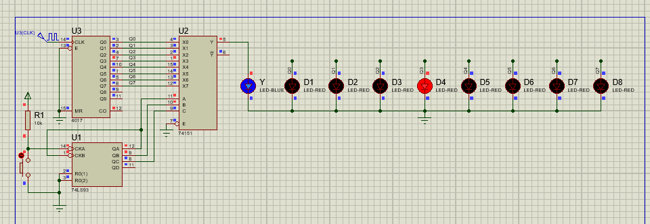

Figure : Choosing different channel using button

|  |  |  |  |  |
| --- | --- | --- | --- | --- |
|  | LED6 | LED5 | LED4 |  |
| Clock Pulse | Q2 | Q1 | Q0 | Channel |
| 0 | 0 | 0 | 0 | X0 |
| 1 | 0 | 0 | 1 | X1 |
| 2 | 0 | 1 | 0 | X2 |
| 3 | 0 | 1 | 1 | X3 |
| 4 | 1 | 0 | 0 | X4 |
| 5 | 1 | 0 | 1 | X5 |
| 6 | 1 | 1 | 0 | X6 |
| 7 | 1 | 1 | 1 | X7 |

**Operation:** By pressing the button output Y pin of ic 74151 will equal to the corresponding input.

**Example:** Like in figure 1, after pressing the button 3 time the output Y will equal to X3.

## PWM with 8 different level

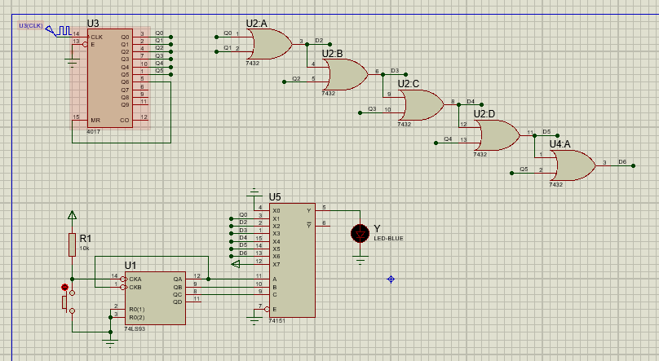

Figure : PWM with button to control LED

**Operational:** This circuit provide 8 different level of lighting of the LED where,

* When press the button 0 time:

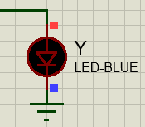

Figure : LED is on but not visibly

* When press the button 2 time:

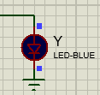

Figure : LED is on level 2

* When press the button 3 times:

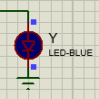

Figure : LED is on level 3

* When press the button 4 times:

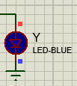

Figure : LED is on level 4

* When press the button 5 times:

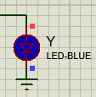

Figure : LED is on level 5

* When press the button 6 times:

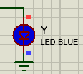

Figure : LED is on level 6

* When press the button 7 times:

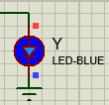

Figure : LED is on maxmimum effect

# 74LS148

## Encoder 8_3

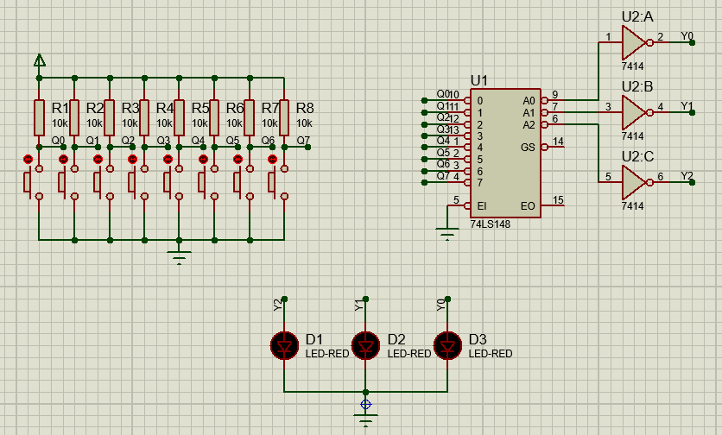

Figure : Encoder 8_3

**Opreational:** Pressing each button from left to right will get the corresponding 3 bit number output however it does not hold the output to visibilize it.

**Example:** From the figure below, it can be seen that when press button 2 it give out the corresponding binary 3 bit number output of 010.

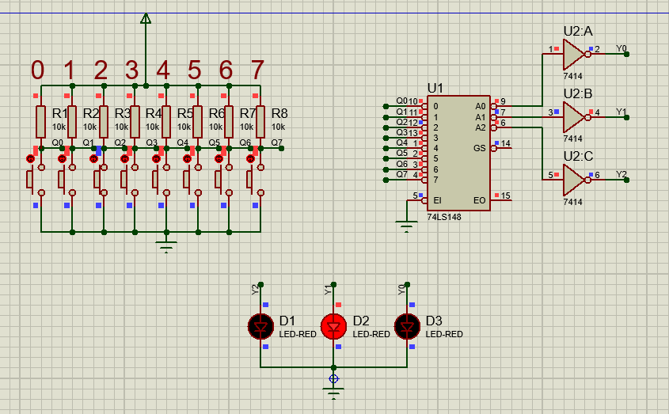

Figure : Encoder 8_3 when pressing button 2

## Encoder 8_3 and using ic74LS175 to latch the result.

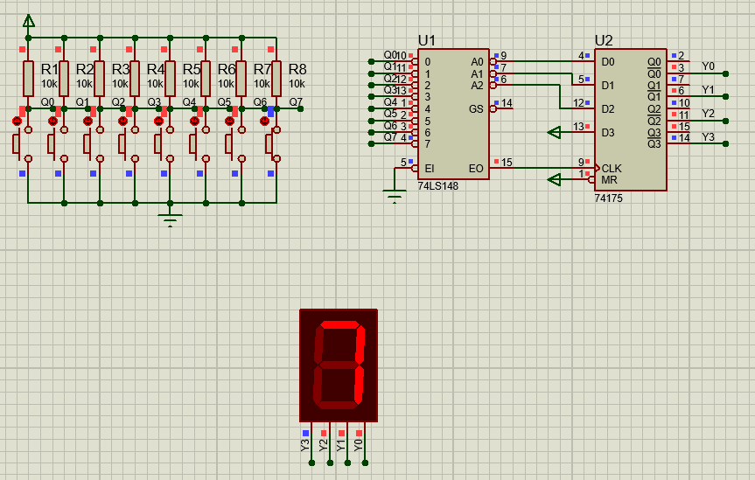

Figure :Encoder 8_3 using 74LS175 to latch the result

**Operational:** First used 74LS148 to decode which button press then using EO pin from 74LS148 to create a clock pulse to latch the result from D pin to Q pin.

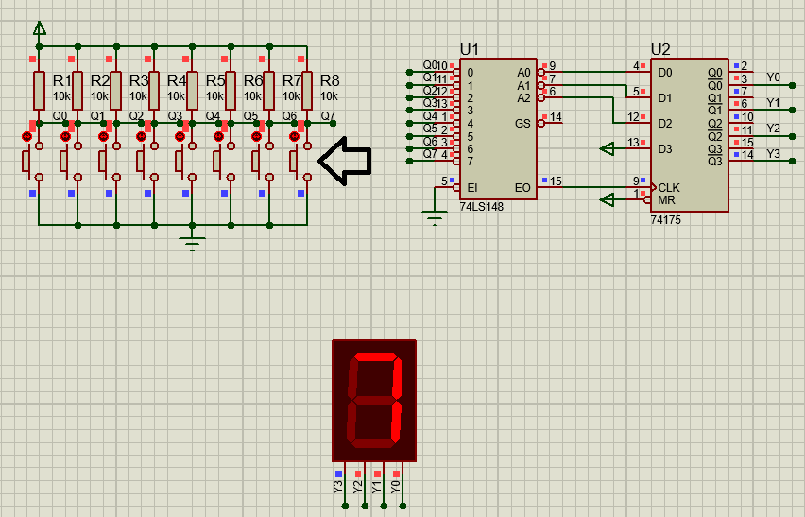

Figure : After letting go of the button

## Encoder 8_3 using two IC 74LS175 to latch the result and shift the previous result

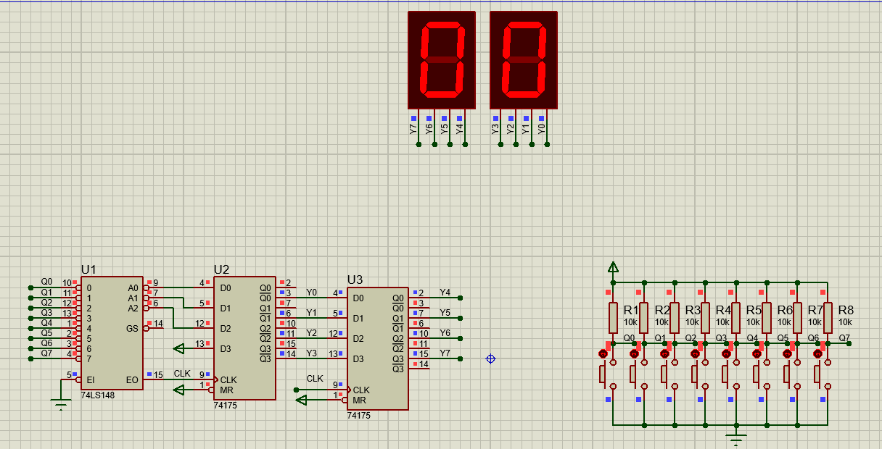

Figure : Encoder 8_3 using 2 IC 74LS175 to latch and shift the result

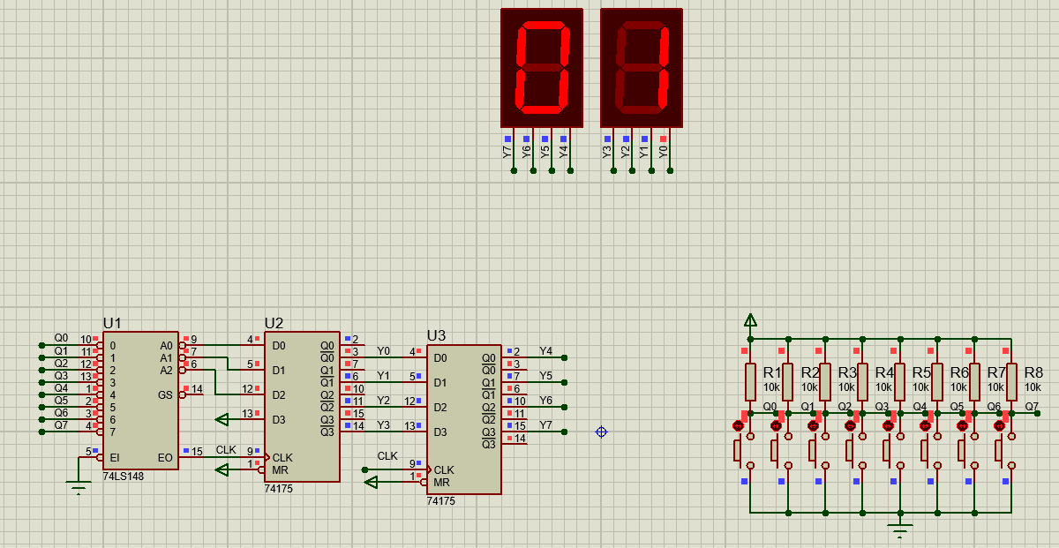

Figure : After pressing button Q1

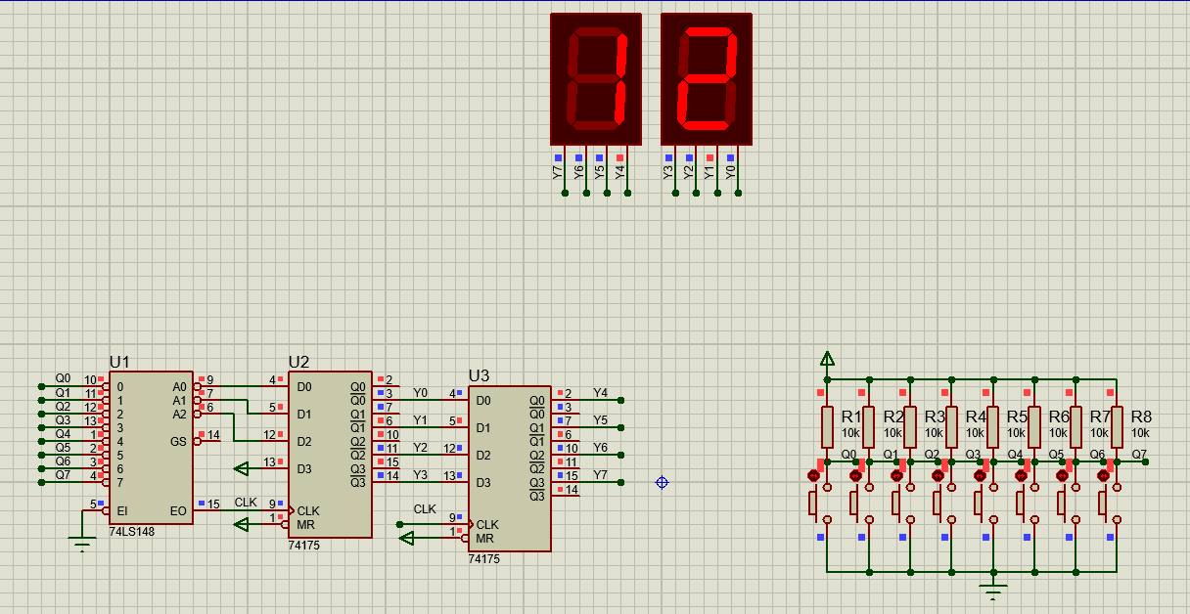

Figure : After pressing button Q2

**Operational:** Like in figure 14 and figure 15, it can be seen that by pressing button Q1 it latched out the new result which is 1 and shift result 0 to the other LED, similarly for figure 16 after pressing Q2 the new result is 2 and the previous result which is 1 got shifted.

# 74LS138

## Decoder decode after 4 clock pulse circuit

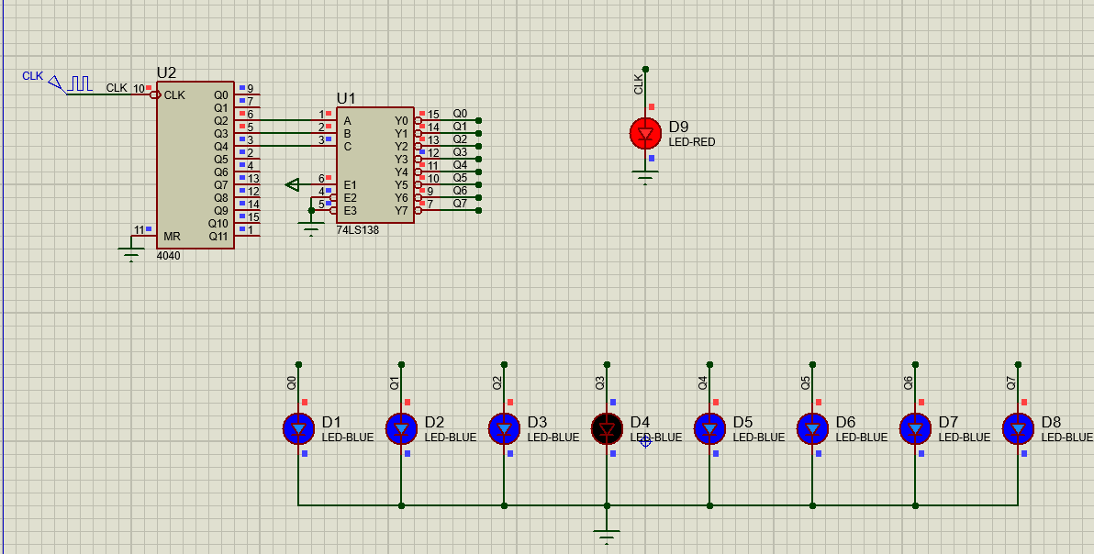

Figure : Decoder decode after 4 clock pulse circuit

**Question:**

1. How many pulse is LED 1 (Y0) on and off?
2. What HEX number is when LED 1 off?
3. What HEX number is when LED 5 off?
4. Operation of the circuit:

|  |  |  |  |  |  |  |  |  |  |  |  |  |  |  |
| --- | --- | --- | --- | --- | --- | --- | --- | --- | --- | --- | --- | --- | --- | --- |
| Input | | | | | | Hex | Output | | | | | | | |
| CP1 | Q4 | Q3 | Q2 | Q1 | Q0 | Y7 | Y6 | Y5 | Y4 | Y3 | Y2 | Y1 | Y0 |
| 0 | 0 | 0 | 0 | 0 | 0 | 00 | 1 | 1 | 1 | 1 | 1 | 1 | 1 | 0 |
| 1 | 0 | 0 | 0 | 0 | 1 | 01 | 1 | 1 | 1 | 1 | 1 | 1 | 1 | 0 |
| 2 | 0 | 0 | 0 | 1 | 0 | 02 | 1 | 1 | 1 | 1 | 1 | 1 | 1 | 0 |
| 3 | 0 | 0 | 0 | 1 | 1 | 03 | 1 | 1 | 1 | 1 | 1 | 1 | 1 | 0 |
| 4 | 0 | 0 | 1 | 0 | 0 | 04 | 1 | 1 | 1 | 1 | 1 | 1 | 0 | 1 |
| 5 | 0 | 0 | 1 | 0 | 1 | 05 | 1 | 1 | 1 | 1 | 1 | 1 | 0 | 1 |
| 6 | 0 | 0 | 1 | 1 | 0 | 06 | 1 | 1 | 1 | 1 | 1 | 1 | 0 | 1 |
| 7 | 0 | 0 | 1 | 1 | 1 | 07 | 1 | 1 | 1 | 1 | 1 | 1 | 0 | 1 |
| 8 | 0 | 1 | 0 | 0 | 0 | 08 | 1 | 1 | 1 | 1 | 1 | 0 | 1 | 1 |
| 9 | 0 | 1 | 0 | 0 | 1 | 09 | 1 | 1 | 1 | 1 | 1 | 0 | 1 | 1 |
| 10 | 0 | 1 | 0 | 1 | 0 | 0A | 1 | 1 | 1 | 1 | 1 | 0 | 1 | 1 |
| 11 | 0 | 1 | 0 | 1 | 1 | 0B | 1 | 1 | 1 | 1 | 1 | 0 | 1 | 1 |
| 12 | 0 | 1 | 1 | 0 | 0 | 0C | 1 | 1 | 1 | 1 | 0 | 1 | 1 | 1 |
| 13 | 0 | 1 | 1 | 0 | 1 | 0D | 1 | 1 | 1 | 1 | 0 | 1 | 1 | 1 |
| 14 | 0 | 1 | 1 | 1 | 0 | 0E | 1 | 1 | 1 | 1 | 0 | 1 | 1 | 1 |
| 15 | 0 | 1 | 1 | 1 | 1 | 0F | 1 | 1 | 1 | 1 | 0 | 1 | 1 | 1 |
| 16 | 1 | 0 | 0 | 0 | 0 | 10 | 1 | 1 | 1 | 0 | 1 | 1 | 1 | 1 |
| 17 | 1 | 0 | 0 | 0 | 1 | 11 | 1 | 1 | 1 | 0 | 1 | 1 | 1 | 1 |
| 18 | 1 | 0 | 0 | 1 | 0 | 12 | 1 | 1 | 1 | 0 | 1 | 1 | 1 | 1 |
| 19 | 1 | 0 | 0 | 1 | 1 | 13 | 1 | 1 | 1 | 0 | 1 | 1 | 1 | 1 |
| 20 | 1 | 0 | 1 | 0 | 0 | 14 | 1 | 1 | 0 | 1 | 1 | 1 | 1 | 1 |
| 21 | 1 | 0 | 1 | 0 | 1 | 15 | 1 | 1 | 0 | 1 | 1 | 1 | 1 | 1 |
| 22 | 1 | 0 | 1 | 1 | 0 | 16 | 1 | 1 | 0 | 1 | 1 | 1 | 1 | 1 |
| 23 | 1 | 0 | 1 | 1 | 1 | 17 | 1 | 1 | 0 | 1 | 1 | 1 | 1 | 1 |
| 24 | 1 | 1 | 0 | 0 | 0 | 18 | 1 | 0 | 1 | 1 | 1 | 1 | 1 | 1 |
| 25 | 1 | 1 | 0 | 0 | 1 | 19 | 1 | 0 | 1 | 1 | 1 | 1 | 1 | 1 |
| 26 | 1 | 1 | 0 | 1 | 0 | 1A | 1 | 0 | 1 | 1 | 1 | 1 | 1 | 1 |
| 27 | 1 | 1 | 0 | 1 | 1 | 1B | 1 | 0 | 1 | 1 | 1 | 1 | 1 | 1 |
| 28 | 1 | 1 | 1 | 0 | 0 | 1C | 0 | 1 | 1 | 1 | 1 | 1 | 1 | 1 |
| 29 | 1 | 1 | 1 | 0 | 1 | 1D | 0 | 1 | 1 | 1 | 1 | 1 | 1 | 1 |
| 30 | 1 | 1 | 1 | 1 | 0 | 1E | 0 | 1 | 1 | 1 | 1 | 1 | 1 | 1 |
| 31 | 1 | 1 | 1 | 1 | 1 | 1F | 0 | 1 | 1 | 1 | 1 | 1 | 1 | 1 |
| 32 | 0 | 0 | 0 | 0 | 0 | 20 | 1 | 1 | 1 | 1 | 1 | 1 | 1 | 0 |
| 33 | 0 | 0 | 0 | 0 | 1 | 21 | 1 | 1 | 1 | 1 | 1 | 1 | 1 | 0 |

Figure : Operating status of the circuit decoder decode after 4 clock pulse

**Answer:**

1. LED 1 (Y0) is:
   * On for 28 clock pulse (from pulse 4 to pulse 28).
   * Off for 4 clock pulse (from pulse 0 to pulse 3).
2. LED 1 (Y0) is off from hex number 00 to 03.
3. LED 5 (Y4) is off from hex number 10 to 13.
4. Operational: Q4Q3Q2 is counted every 4 clock pulse pass so when we connect Q4Q3Q2 to CBA the corresponding code of Q4Q3Q2 will turn off that respective light and move to the next after 4 clock pulse have pass.

## Decoder decode after 8 clock pulse circuit

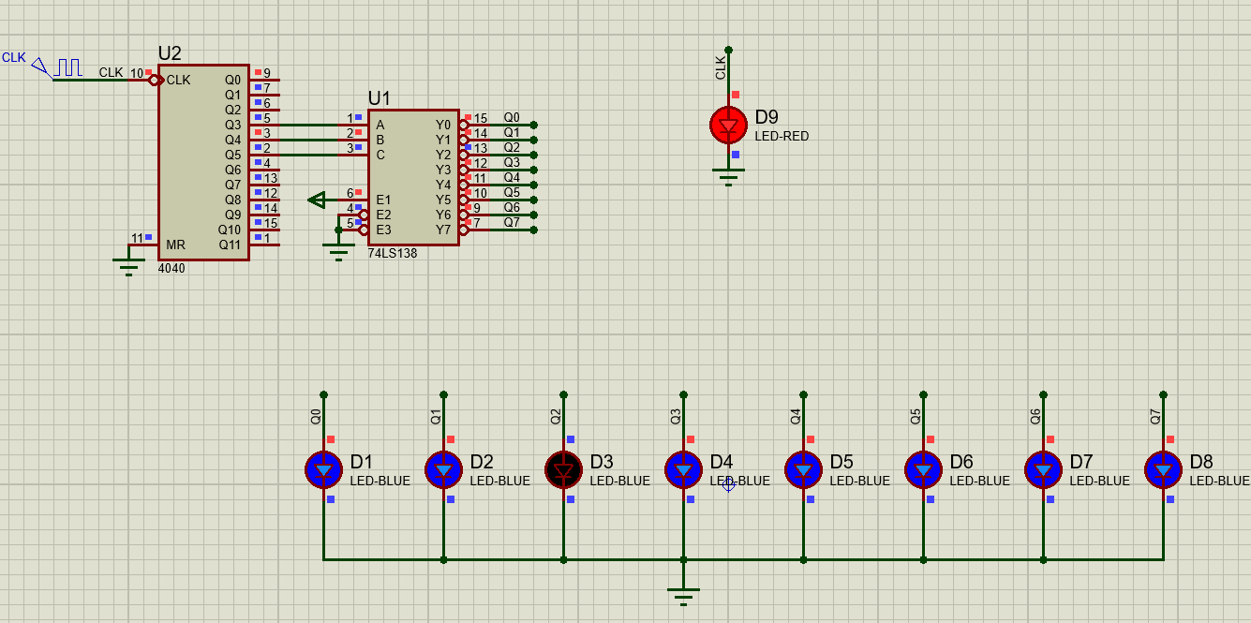

Figure : Decoder decode after 8 clock pulse

**Operational:** Q5Q4Q3 is counted every 4 clock pulse pass so when we connect Q5Q4Q3 to CBA the corresponding code of Q5Q4Q3 will turn off that respective light and move to the next after 8 clock pulse have pass.

## Decoder decode after 128 clock pulse circuit

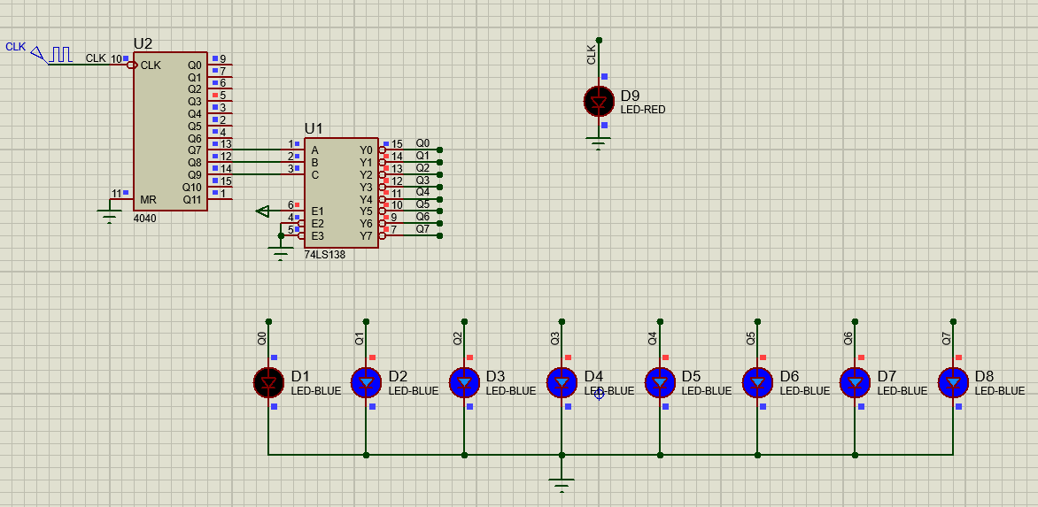

Figure : Decoder decode after 128 clock pulse

**Operational:** Q9Q8Q7 is counted every 4 clock pulse pass so when we connect Q9Q8Q7 to CBA the corresponding code of Q9Q8Q7 will turn off that respective light and move to the next after 128 clock pulse have pass.

## Decoder decode after 256 clock pulse circuit

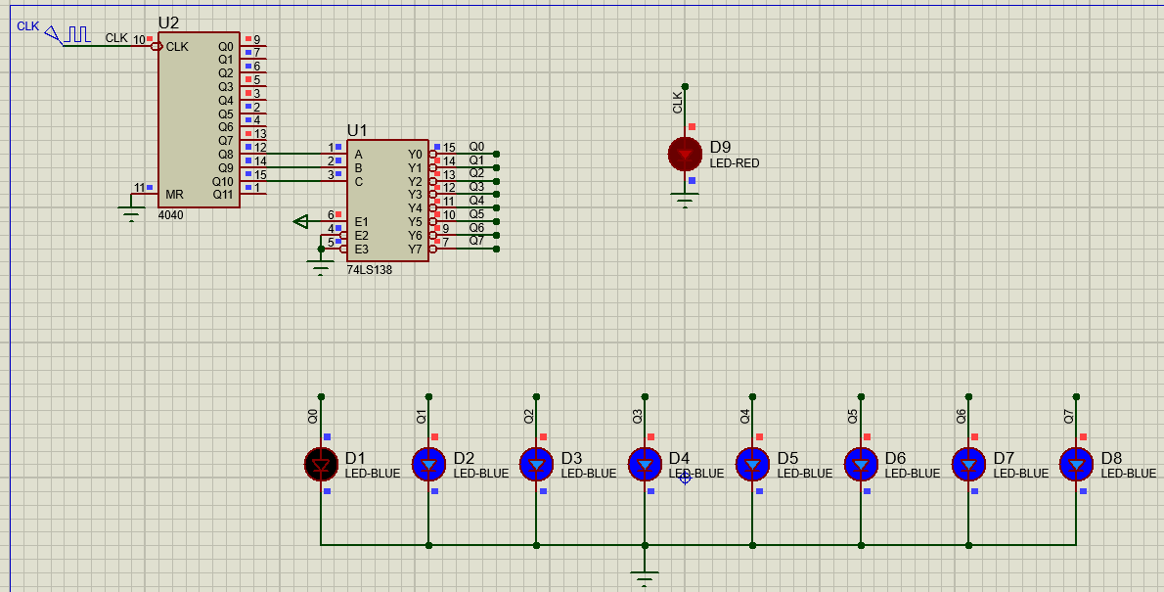

Figure : Decoder decode after 256 clock pulse

**Operational:** Q10Q9Q8 is counted every 4 clock pulse pass so when we connect Q10Q9Q8 to CBA the corresponding code of Q10Q9Q8 will turn off that respective light and move to the next after 256 clock pulse have pass.

## Creating a decoder 4_16 using 2 decoder 3_8

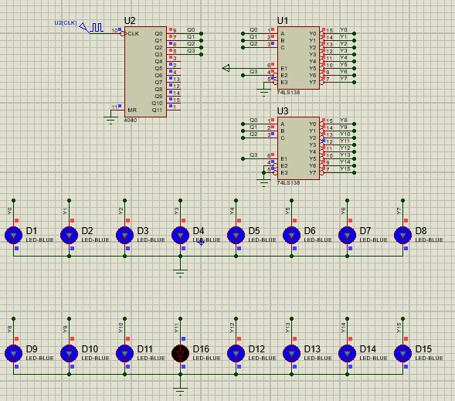

Figure : Decoder 4_16 using 2 decoder 3_8

**Operational:** By connecting Q3 the MSB of 4 bit binary number to E2 pin of 1st decoder and E1 of the 2nd decoder the 1st decoder will decode the first 8 binary number and after that it will be disable until the 2nd decoder finish decoding the other 8 binary number then repeat the process.

## Demultiplexer

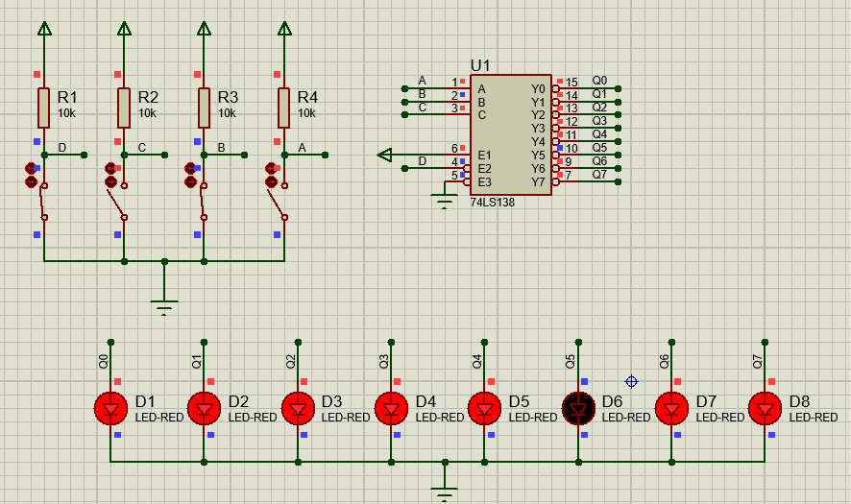

Figure : Demultiplexer

**Operational:** With the input CBA it will let swich D control the corresponding LED.

## Multiplexer and Demultiplexer with 8 chanel

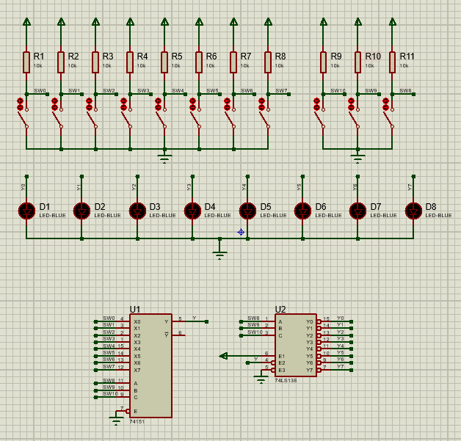

Figure : Multiplexer

**Operational:** By controlling the input CBA to what number it will control it’s corresponding output with the corresponding input and lock all other switch.

**Example:** If the CBA is send with 011 it will allow SW3 to control the output Y3 and all other output is lock regardless of what signal the other switch send to IC 74LS151.

|  |  |  |  |  |  |  |  |  |  |  |  |  |  |  |  |  |  |  |
| --- | --- | --- | --- | --- | --- | --- | --- | --- | --- | --- | --- | --- | --- | --- | --- | --- | --- | --- |
| 8 Input address | | | | | | | | Address | | | 8 Output address | | | | | | | |
| D7 | D6 | D5 | D4 | D3 | D2 | D1 | D0 | C | B | A | Y7 | Y6 | Y5 | Y4 | Y3 | Y2 | Y1 | Y0 |
| 1 | 1 | 1 | 1 | 1 | 1 | 1 | 0 | 0 | 0 | 0 | 1 | 1 | 1 | 1 | 1 | 1 | 1 | 0 |
| 1 | 1 | 1 | 1 | 1 | 1 | 0 | 1 | 0 | 0 | 1 | 1 | 1 | 1 | 1 | 1 | 1 | 0 | 1 |
| 1 | 1 | 1 | 1 | 1 | 0 | 1 | 1 | 0 | 1 | 0 | 1 | 1 | 1 | 1 | 1 | 0 | 1 | 1 |
| 1 | 1 | 1 | 1 | 0 | 1 | 1 | 1 | 0 | 1 | 1 | 1 | 1 | 1 | 1 | 0 | 1 | 1 | 1 |
| 1 | 1 | 1 | 0 | 1 | 1 | 1 | 1 | 1 | 0 | 0 | 1 | 1 | 1 | 0 | 1 | 1 | 1 | 1 |
| 1 | 1 | 0 | 1 | 1 | 1 | 1 | 1 | 1 | 0 | 1 | 1 | 1 | 0 | 1 | 1 | 1 | 1 | 1 |
| 1 | 0 | 1 | 1 | 1 | 1 | 1 | 1 | 1 | 1 | 0 | 1 | 0 | 1 | 1 | 1 | 1 | 1 | 1 |
| 0 | 1 | 1 | 1 | 1 | 1 | 1 | 1 | 1 | 1 | 1 | 0 | 1 | 1 | 1 | 1 | 1 | 1 | 1 |

Figure : Operating status of the multiplexer circuit

# 74LS139

## Decoder 3_8 using 2 IC 74LS139

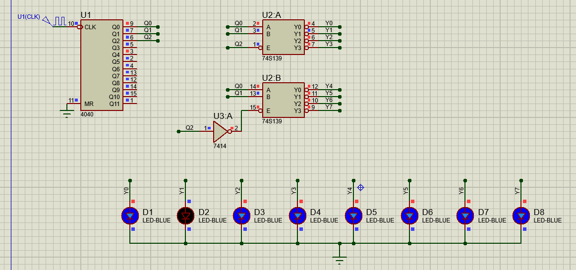

Figure : Decoder 3_8 using 2 IC 74LS139

Operational: By connecting Q2 the MSB of 3 bit binary number to E pin of 1st decoder and the IC7414 then to the E pin of the 2nd decoder the 1st decoder will decode the first 4 binary number and after that it will be disable until the 2nd decoder finish decoding the other 4 binary number then repeat the process.